**HTML (HYPER TEXT MARKUP LANGUAGE)**

**Basic Structure of HTML:** <html>

<head>

<title>Basic Structure</title>

</head>

<body>

Basic structure of <b>HTML</b><br>

THIS IS MY FIRST WEB PAGE.

</body>

</html>

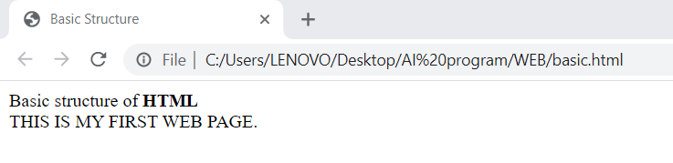

**Meta Tags in HTML**

<html>

<head>

<meta name="author" content="Saini">

<meta name="revised" content=“12/13/2022">

<meta name="generator" content="Macromedia Dreamweaver 2012">

<meta name="description" content="HTML examples">

<meta name="keywords" content="HTML, DHTML, CSS, JavaScript, PHP">

</head>

<body>

<p>

The meta attributes of this document identify the author and the editor software.

<p>

The meta attributes of this document describe the document and its keywords.

</p> </p>

</body>

</html>

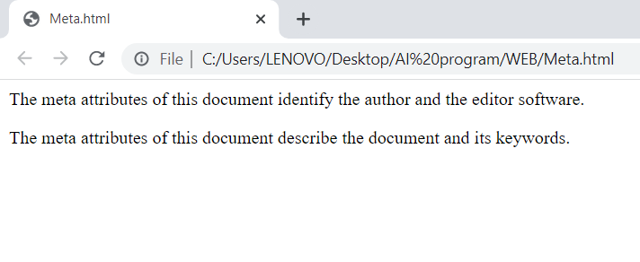

**Heading, BR and Paragraph Tag:**

<html>

<head>

<title>

Heading Tag Demonstration

</title>

</head>

<body>

<h1>Hello</h1>

<h2 align=center>Hello</h2>

<h3>Hello</h3>

<h4 align=right>Hello</h4>

<h5>Hello</h5>

<h6>Hello</h6>

Welcome to my website

<b>My Name is Saini Thapa Magar</b>

<br> Demonstration for br(line break)

<p>Now I am using the paragraph tag.</p> </body></html>

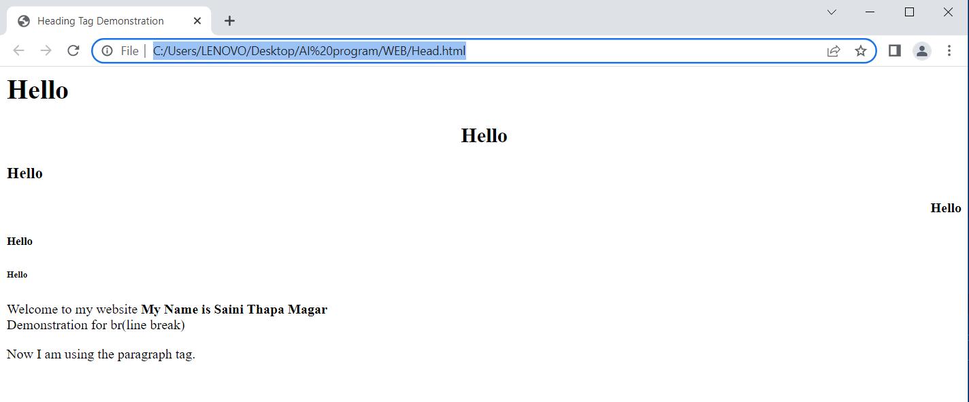

**Text Formatting tags:**

<html>  
<body>

<b> WELCOME TO MY PLAYGROUND</b><br>

<strong>This is strong text</strong><br>

<big> This is big text</big><br>

<em>Emphasized Text it is</em><br>

<i>This is Italic Font</i><br>

<small>Small text</small><br>

Example for subscript: H<sub>2</sub>O<br>

Example for superscript: a<sup>2</sup>-b<sup>2</sup> = (a+b)(a-b)<br>

</body></html>

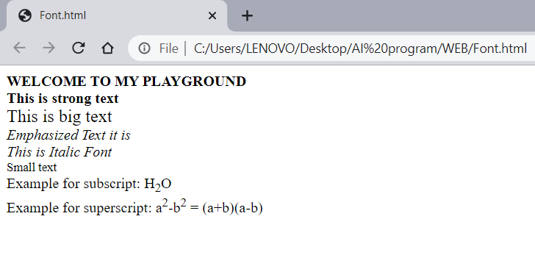

**Font and Background in HTML:**  
<html>  
<body background="c.png ">  
<font face="Verdana" size="4" color="black">  
It’s me in Verdana text font.  
</font> <br>  
<font face="Times" size="7" color="magenta">  
This is Times New Roman Font.  
</font> <br>  
<hr color="Turquoise">  
<address>  
Shankarnagar, Tilotama, Nepal  
</address>  
© Saini Thapa <! COPYRIGHTED>  
</body>  
</html>

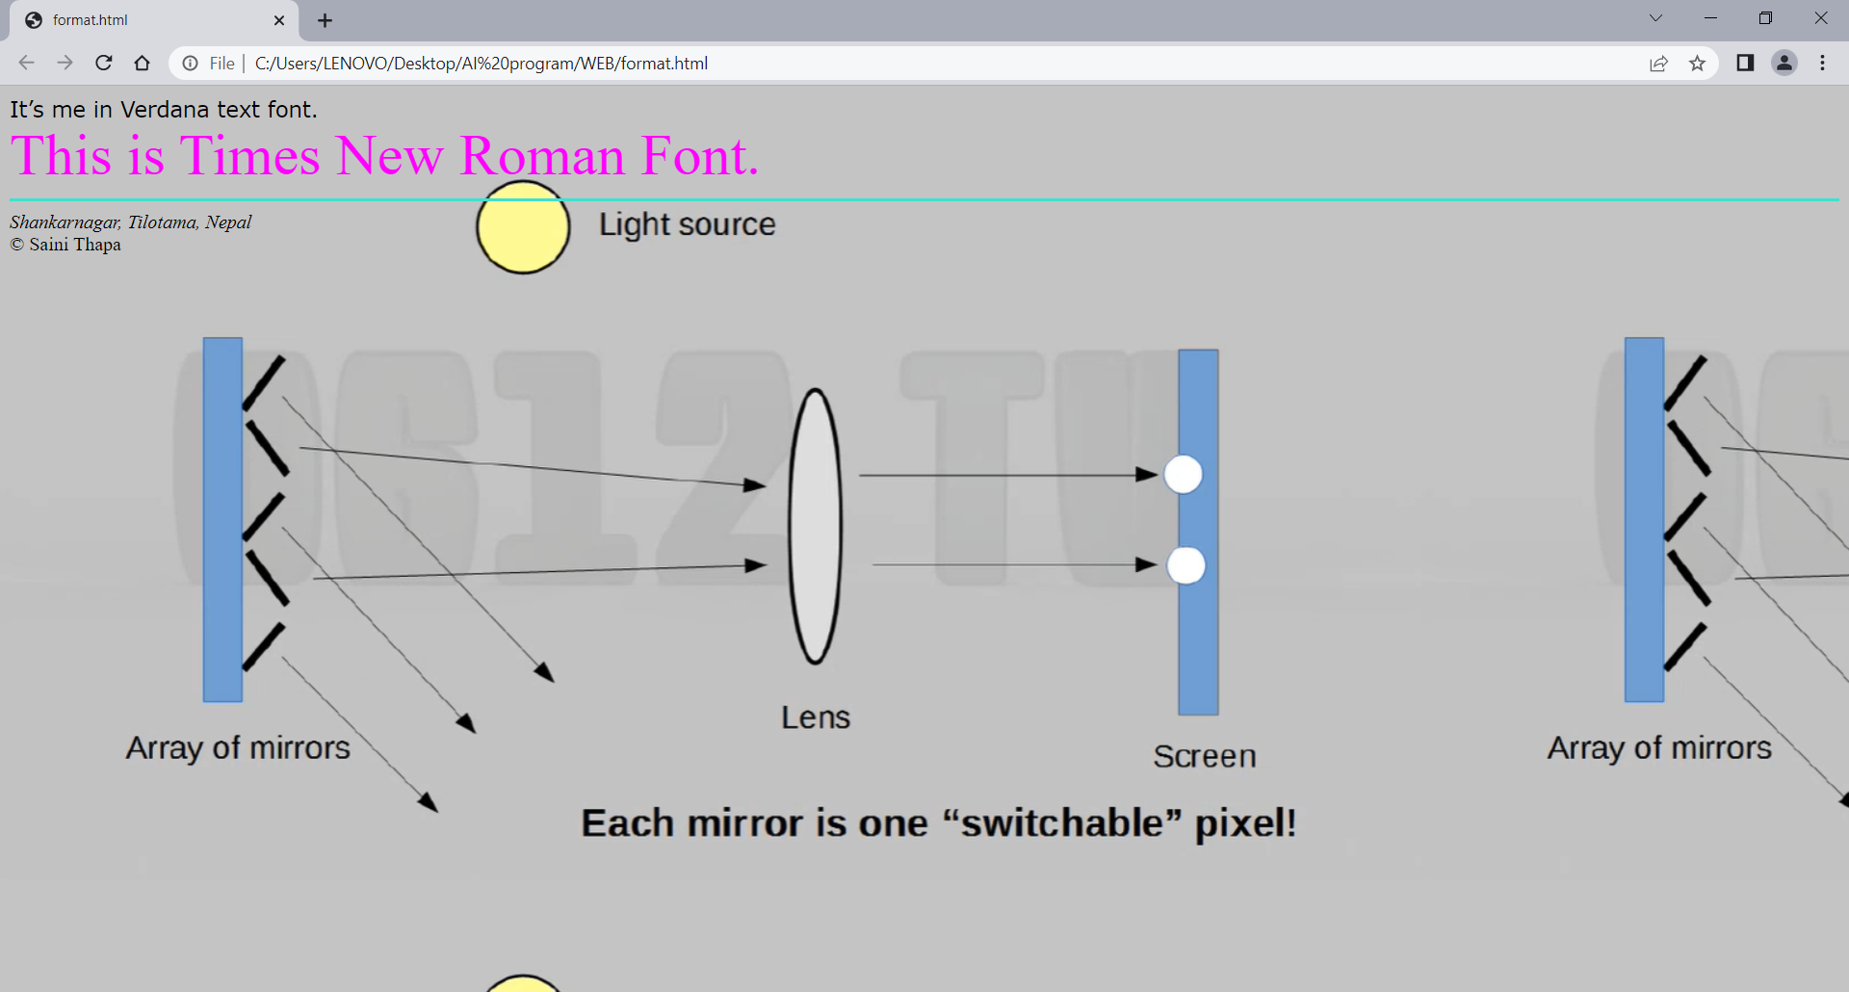

**Formatted Output:**<html>  
<body>  
<pre>

This is

preformatted text.

Hence it will preserve both spaces

and line breaks.  
</pre>

<p><tt>The pre tag is good for displaying </tt>computer code</p>

</body>  
</html>

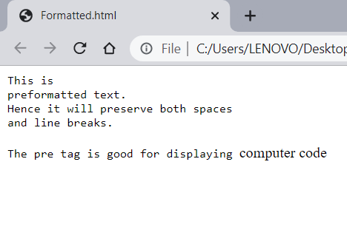

**Floating Image:**

<html>  
<body>  
<p><strong>Float the image to the right</strong></p>

<img src=”me-and-the-boys.jpg” style="float:right;width:80px; height:80px;">

A paragraph with a floating image.

<p><strong>Float the image to the left:</strong></p>

<img src="me-and-the-boys.jpg" style="float:left;width:100px;height:100px;">

A paragraph with a floating image.

</p></body></html>

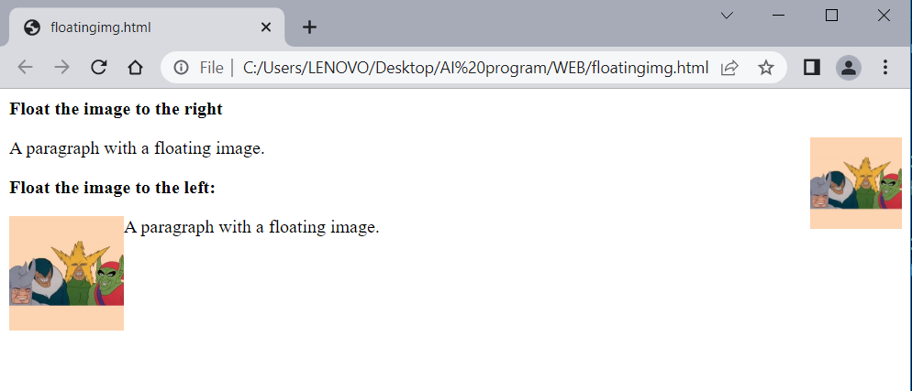

**Anchor and Marquee tag:**

<html>  
<body> <marquee direction="right" behavior="alternate"><a  
href="https://www.qfxcinemas.com/show?eventId=7829 ">  
Click here to book your ticket now.  
</a>  
</marquee>  
</body>  
</html>

Before clicking on the hyperlink:

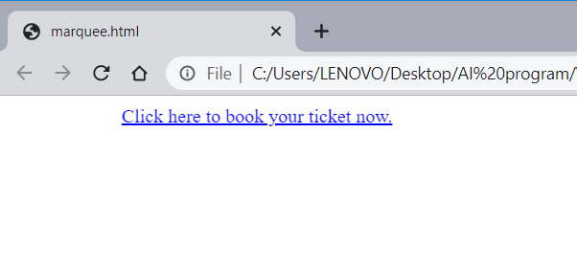

After clicking on the hyperlink:

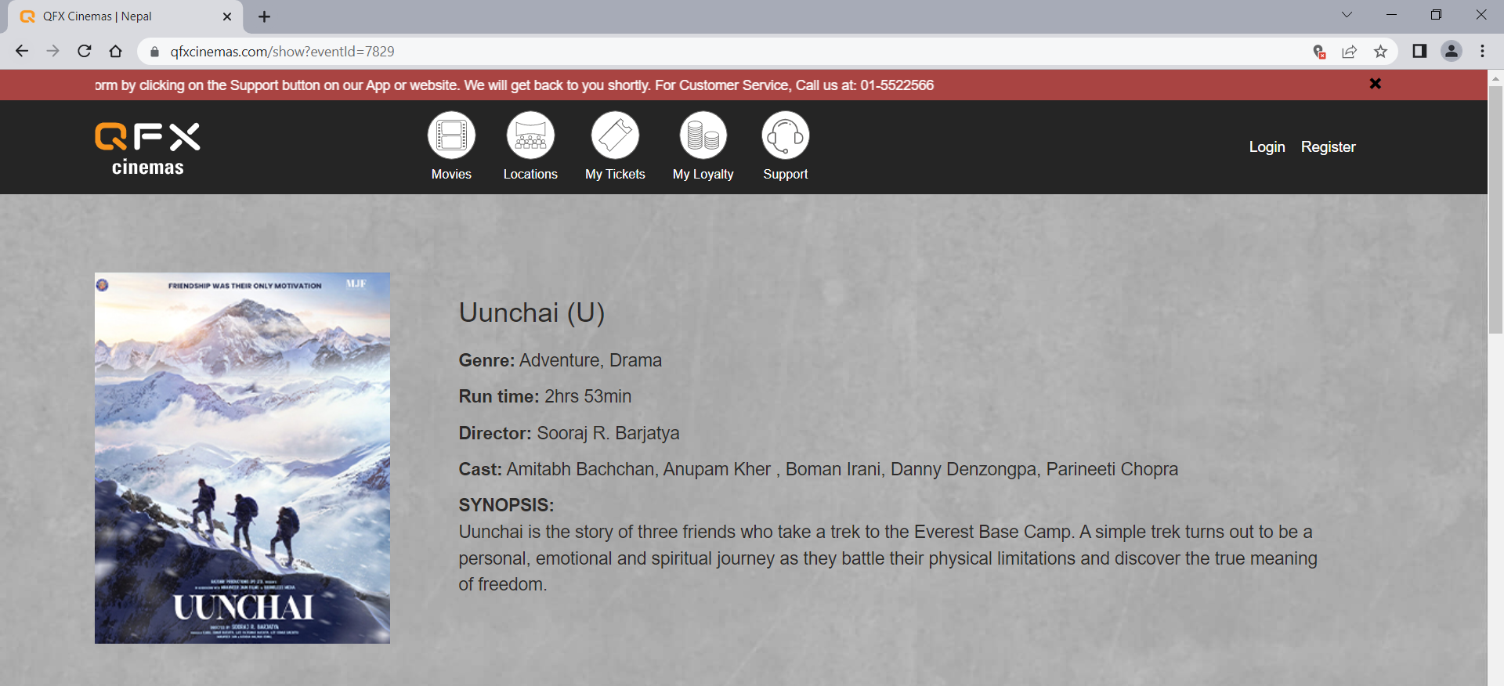

**HTML lists:**

<html>

<head>

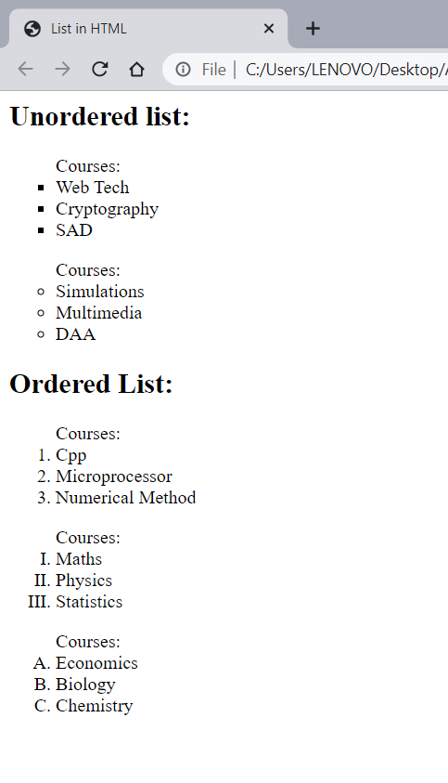<title>List in HTML</title>

</head>

<body>

<h2>Unordered list:</h2>

<ul type="Square">Courses:

<li>Web Tech</li>

<li>Cryptography</li>

<li>SAD</li>

</ul>

<ul type="circle">Courses:

<li>Simulations</li>

<li>Multimedia</li>

<li>DAA</li>

</ul>

<h2>Ordered List:</h2>

<ol type="1" >Courses:

<li>Cpp </li>

<li>Microprocessor</li>

<li>Numerical Method</li>

</ol>

<ol type="I" >Courses:

<li>Maths </li>

<li>Physics</li>

<li>Statistics</li>

</ol><ol type="A" >Courses:

<li>Economics</li>

<li>Biology</li>

<li>Chemistry</li>

</ol>

</body>

</html>

**HTML Tables (Border, spacing, Background, align) :**<html>

<head>

<title>Tables</title>

<style>

table,td,tr,th{

border: 1px solid black;

border-collapse: collapse;

padding:1rem;

}

</style>

</head>

<body>

<caption>Students Record:</caption>

<table >

<tr bgcolor="Orange">

<th>Name</th>

<th colspan="2" align="left">Phone</th>

</tr>

<tr bgcolor="#00ff34">

<td rowspan="2">Saini</td>

<td>Ncell</td>

<td>NTC</td>

</tr>

<tr bgcolor="magenta">

<td>+977-9847688769</td>

<td>+977-9807412345</td>

</tr>

</table>

</body>

</html>

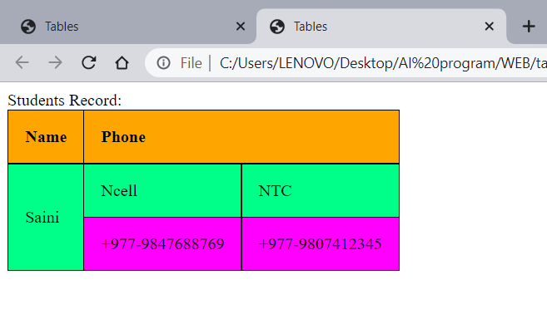

**HTML Frames:**<html>

<body>

<iframe width="560" height="315" src="https://www.youtube.com/embed/BsDoLVMnmZs"

title="YouTube video player" frameborder="0" allow="accelerometer; autoplay; clipboardwrite; encrypted-media; gyroscope; picture-in-picture" allowfullscreen></iframe>

</body></html>

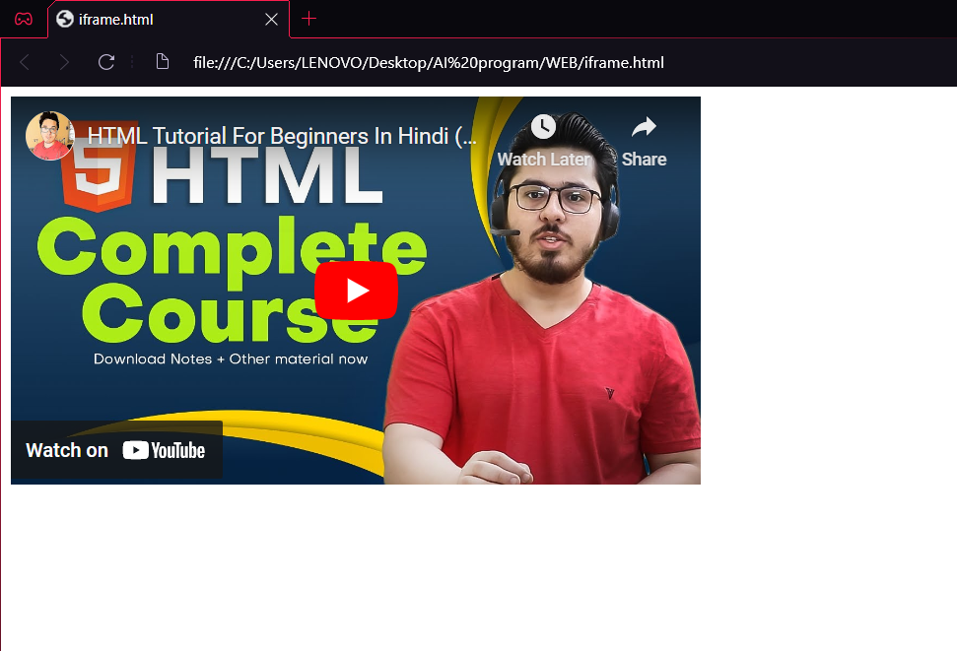

**Form (Input, action, select):**

<html>

<body>

<form>

<label for="username">Username:</label><br>

<input type="text" name="username"><br>

<label for="pwd">Password:</label><br>

<input type="password" name="pwd"><br>

<input type="radio" name="gender" value="male">

<label for="male">Male</label><br>

<input type="radio" name="gender" value="female">

<label for="female">Female</label><br>

<input type="radio" name="gender" value="other">

<label for="other">Other</label><br>

<input type="radio" name="gender" value="Anonymous">

<label for="Anonymous">Prefer not to say</label><br><br>

<label><strong>What do you prefer most?</strong> </label><br>

<input type="checkbox" value="Bike">

<label> I have a bike</label><br>

<input type="checkbox" value="Car">

<label> I have a car</label><br>

<input type="checkbox" value="Bus">

<label> I have a Bus</label><br>

<input type = "checkbox" value="None">

<label>None of the above</label><br><br>

<strong>Who is your benchmate? </strong> <br>

<select name="Best friend" size="3">

<option value="Santosh">Santosh</option>

<option value="Sushil">Sushil</option>

<option value="Shreejan">Shreejan</option>

<option value="Suman">Suman</option>

<option value="Vishan">Vishan</option>

<option value="Tilak">Tilak</option>

</select><br><br>

<b>Upload an clear image of your Citizenship (front/back): </b><br>

<label>Choose a file: </label><input type="file" /><br><br>

<select>

<option> Select your country </option>

<option value="NP"> Nepal </option>

<option value="IND"> India </option>

<option value="CHN"> China </option>

<option value="JPN"> Japan </option>

<option value="SK"> South Korea </option>

<option value="UK"> United Kingdom </option>

<option value="USA"> United States of America </option>

</select><br>

<textarea rows="10" cols="30">Post your Feedback here</textarea><br>

<input type="reset" value="Reset all Data" /><br>

<input type="submit" value="Submit">

</form>

</body>

</html>

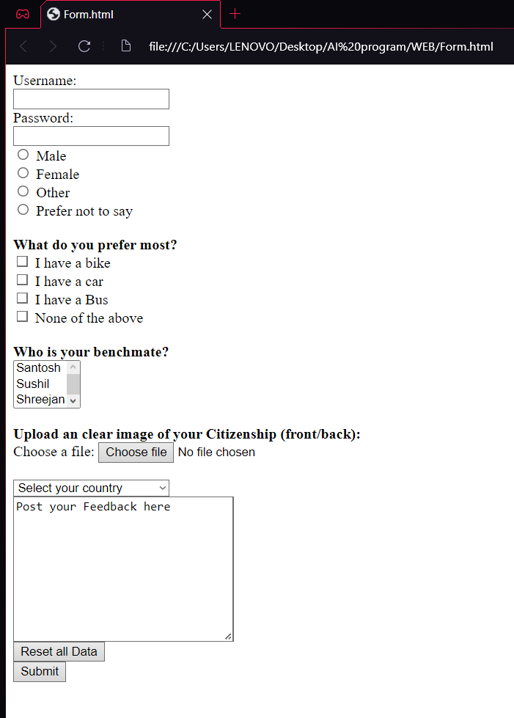

**Audio, Video:**

<html>

<body>

<audio controls muted loop>

<source src="mR.mp3" type="audio/mp3"> </audio>

<video controls autoplay muted width="800px" height="500px"">

<source src="GirlsGeneration.mp4" type="video/mp4"></video>

<canvas id="myCanvas" width="800" height="200" style="border:3px solid #ff00ee;">

</canvas>

</body>

</html>

